DECODING MENTAL ROTATION

*From Motor and Premotor Activation*

By

Dedeepya Konuthula

Neuroscience Honors Thesis

May 28, 2014

Department of Psychological and Brain Sciences

Dartmouth College

Advisor: Peter U. Tse, Ph.D.

Second Reader: Thalia Wheatley, Ph.D.

TABLE OF CONTENTS

ACKNOWLEDGEMENTS 2

ABSTRACT 3

INTRODUCTION 4

METHODS 8

RESULTS 16

DISCUSSION 23

REFERENCES 26

ACKNOWLEDGEMENTS

This project would not have been possible without the help of Alexander Schlegel and Prescott (Scottie) Alexander. When I first signed up to work in Professor Tse’s lab as a James O. Freedman Presidential Scholar my sophomore summer, Alex took me under his wing. He provided the direction that I didn’t have and the confidence in my abilities that I couldn’t find. At that point, a Senior Honors Thesis felt like an immense undertaking and one well beyond my skill level. Almost from the beginning, Alex would casually bring it up: “This could be a cool topic for a thesis.” “If you decide to write a thesis, you could explore that issue further.” “We can’t look at that in this study, but if you do a thesis, that might be a good option.” I thought that, over time, he would realize I couldn’t do it. Instead, over time, he taught me that I could. Thank you, Alex, for believing in me before I believed in myself.

If Alex guided me through the big picture, Scottie filled in the little details. Scottie, sorry for interrupting your work with Matlab questions a million and one times over the past couple of years, and thank you for never minding. Alex and Scottie have been immense sources of guidance and inspiration. I would like to thank them both for all the time they spent over the past years teaching me everything I needed to learn to complete this project as well as for their infinite patience and encouragement throughout this process.

Xiaotian (Dennis) Wu, thank you for always taking the time out of your own packed schedule to spend long hours down in the scanner as my Scan Buddy—often at short notice.

Thank you to my primary advisor, Peter U. Tse, PhD, and my secondary advisor, Thalia Wheatley, PhD, for their guidance and feedback throughout this process.

ABSTRACT

In this study, we hoped to gain a more detailed understanding of whether mental rotation can be executed via two discernible pathways as well as if and how the distributed neural network of which we found evidence in our past work (Schlegel et. al, 2013) facilitates the execution of this mental operation. To this end, we adapted the training paradigm of Kosslyn (2001) and randomly assigned participants to one of two training groups—an animation group which learned the task by watching videos of rotating stimuli and a model group which learned the task by manually rotating physical representations of the stimuli. We hypothesized that motor simulation of mental rotation would manifest as the core network consisting of dorsolateral prefrontal cortex, frontal eye fields, occipital cortex, lateral occipital cortex, precuneus, and posterior parietal cortex recruiting motor areas such as primary motor cortex, premotor cortex, supplementary motor area (sma), and pre-sma to execute different types of mental rotations and that this motor simulation would have a stronger effect in the group which learned the task through manual rotation. Participants attended a behavioral training session in which learned how to carry out each of four different types of mental rotations. Each training group did not know about the existence of the other to avoid bias. In the fMRI scanner, both groups had identical experiences. After an MVPA analysis, we found that the regions of interest in which we could classify among the different types of mental rotations were consistent with our previous work and supported the existence of a widely distributed core network which forms the basis of our ability to manipulate mental representations. This network did appear to recruit motor areas to accomplish the task.

INTRODUCTION

Although most humans can manipulate mental images with ease, this manipulation is undeniably a complex neural feat which forms the core of different types of mental operations. Our ability to visualize and alter our mental representations of images--sometimes even represent images we have never seen--is fascinating. Picture the most comfortable armchair with which you have experience. You have probably never seen it toppled over with the back of the chair against the ground, but could you picture it in that orientation? Most people can easily call up a mental image of the armchair, mentally rotate it ninety degrees, and make judgments about the rotated image. Imagine that you are a firefighter, and you arrive at a burning house. If you are too large to pass through a partially blocked entrance, can you give clear directions to a frightened child on the other side? In order to do this, you have to mentally manipulate what you can see in order to understand what it looks like from the other side--to give directions according to what the child is seeing. This is another impressive example of mental rotation, the human ability to imagine and predict the two-dimensional appearance of a three-dimensional object viewed at various angles. Mental rotation is just one of the mental operations we are able to perform due to our ability to skillfully manipulate mental imagery.

Mental rotation as a phenomenon was first explored by Shepard and Metzler (1971) over forty years ago. In this study, eight adult participants were presented with sixteen hundred perspective drawings of three dimensional abstract figures and asked to determine if each pair represented the same figure. The two perspectives of each figure varied by some angle of rotation around an axis. Interestingly, the axis of rotation—whether a given rotation was in-plane or in-depth—did not seem to have an effect.

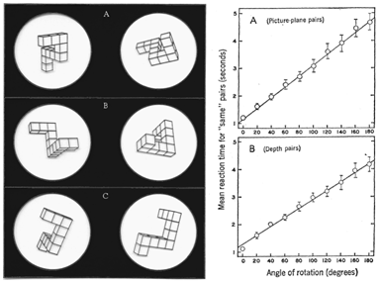The main result was the discovery that participants’ response times varied linearly with the angular difference between the two perspectives. This provided evidence for the existence of analog spatial representations in the mind and jumpstarted the psychological and neuroscientific study of mental rotation (Shepard & Cooper, 1982).

Fig. 1. On left: A, B, C are three examples of the pairs of perspective drawings. On right, A shows the trend in angle of rotation versus response time for an in-plane rotation, while B shows the same trend for an in-depth rotation (Shepard & Metzler, 1971).

With the advent of functional magnetic resonance imaging, subsequent studies were able to begin exploring the neural basis of mental rotation. Early on, fMRI studies found that regions of the posterior frontal cortex previously associated with planning and executing motor responses were activated during mental rotation tasks (Cohen & Bookheimer, 1994). It has been hypothesized that the activation of motor areas during mental rotation could be due to motor simulation, the fact that participants may be simulating manually rotating the stimuli with their hands (Michelon et. al, 2006).

Studies have looked at various ways in which altering experimental conditions can lead to significant changes in patterns of motor activity. For example, the effect of mentally rotating various types of stimuli has been studied. It has been found that a region in the left precentral gyrus is more highly activated when mentally rotating depictions of hands versus mentally rotating abstract figures (Kosslyn et. al, 1998). Subsequent work by Kosslyn et. al (2001) showed that participants may have two different methods of imagining objects rotating and that participants can be trained to use one or the other. In their study, one group of participants was trained by watching a motor rotate an object and then, in the scanner, was told to imagine the figures rotating the way they had seen. The other group of participants was trained by manually rotating objects and then was told, in the scanner, to imagine the figures rotating the way they had just rotated them. The fMRI data showed that primary motor cortex was only activated in the group that imagined manually rotating the stimuli (Kosslyn et. al, 2001).

The present study adopted a similar manipulation in which participants were split into two groups and trained differently. One group was trained by watching animations of stimuli rotating, and one group was trained by manually rotating physical representations of the stimuli. One of our goals in this study was to further explore the recruitment of motor areas by testing whether the participants in the manual rotation group recruited motor areas to a greater extent or in a different way than the participants in the animation group.

While imaging studies have shown that mental rotation tasks are often accompanied by neural activity in motor-related areas such as the primary motor area (Kosslyn et. al, 2001), premotor area (Kosslyn et. al, 1998, 2001; Richter et. al, 2000), and supplementary motor area (SMA; Richter et. al, 2000), whether these motor-related regions play a role in the execution of different types of mental rotations is still unclear. The manipulation of mental imagery is a complex cognitive task, and complex tasks are not often extremely localized in the brain. Based on our previous work, our hypothesis is that complex cognitive tasks, such as constructive imagery and mental rotation, will be accomplished by a distributed network of brain areas which consists of a core as well as a more extended network made up of whichever parts of the brain are recruited for a specific task (Schlegel 2013). Our use of classification analysis instead of a generalized linear model is based on a search for small but informative activity differences across voxels rather than large differences within voxels.

We believe that by conducting a generalized linear model analysis, Kosslyn et. al was not able to capture all of the information in the data (2001). In this study, we hoped to combine the training paradigm from Kosslyn (2001) with the sensitive analytic method of Schlegel (2013) to gain a richer and more nuanced understanding of whether mental rotation can be executed via two different pathways and what role the distributed network of which we found evidence in our past work plays in this operation. In the present study, we hypothesized that the core network consisting of frontal, parietal, and occipital areas would recruit motor areas to execute different types of mental rotations. If a neural activity of a certain brain region contains systematic information which is able to classify among highly confusable types of mental rotation and matches the pattern of confusability built into our task, we believe that this is evidence that this brain area is involved in the execution of different types of mental rotations.

METHODS

Participants

Twenty-two participants (ten females) age 18-23 y participated in the experiment. All were right-handed according to the Edinburgh Handedness Inventory. All participants gave informed consent according to the guidelines of the Institutional Review Board of Dartmouth College. One participant’s data was not analyzed due to experiment error. Participants signed up to participate in both an initial behavioral training session and a functional magnetic resonance imaging (fMRI) session.

Stimulus

The first eight unique images composed of ten cubes from the Mental Rotation Stimulus Library were used as models to generate our own images with the same 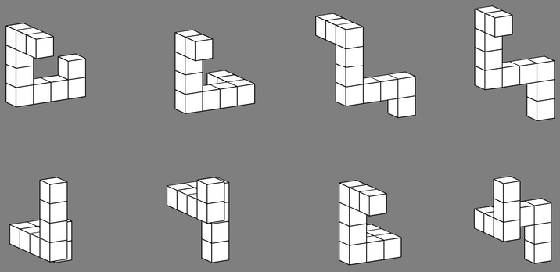configurations in Matlab (Peters & Battista, 2008). The stimulus set consisted of these eight figures, shown in Figure 2, presented in either their original orientation or rotated 180 degrees around one of two axes. During each trial, participants were asked to rotate of these figures. The set of figures they were offered as potential results was more extensive and included all of these figures in additions to their flipped analogues.

Fig. 2. The eight Shepard & Metzler-type stimuli in our stimulus set shown in their original orientations.

While these figures comprised all of the possible stimuli in the fMRI, the behavioral training sessions additionally involved either rotation animations or physical models of the stimuli. The animations were made by generating images of each figure rotated 90 degrees incrementally in either direction in one of two orthogonal planes. These images were used to create animations for each figure in the stimulus set of each type of rotation participants would be asked to do. The physical models of each of the eight figures were constructed of wooden craft cubes with one-half inch edges and painted white with black edges to resemble the images closely.

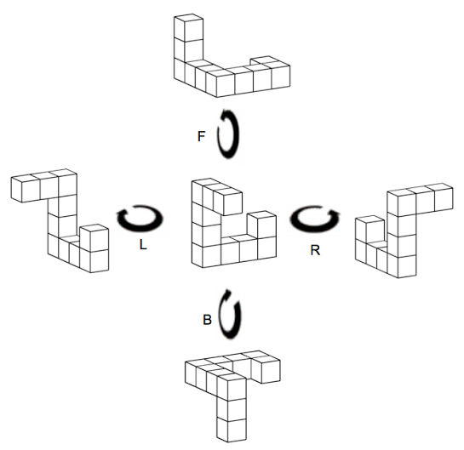Task

In this experiment, the task carried out in the behavioral training session was very similar to the task carried out in the fMRI scanner. Participants performed four types of rotations, as shown in Figure 3. The stimulus figure was presented in some beginning orientation. Superimposed over the figure were the partially transparent letters L, R, B, and F—representing each type of rotation participants could be asked to perform—presented in a random order. A partially transparent number *n* was also superimposed over the stimulus below the letters. *n* (1, 2, 3, or 4) indicated that the participant should perform the type of rotation represented by the letter in the *n*th position. The stimulus stayed on the screen while the participant did the prompted rotation. A blank screen appeared before the test screen. The test screen showed either the correct result of carrying out the prompted rotation on the stimulus or an incorrectly flipped or rotated version of the stimulus. Participants pressed one of two buttons on an input device to indicate whether or not the image on the test screen matched the expected result of their rotation. They then received immediate feedback about whether or not they were correct.

Fig. 3. This represents the four possible types of rotations participants were asked to perform.

During the behavioral training session, participants were given different instructions depending on the training group—animation or model—to which they were randomly assigned. The task was untimed during the training session in order to allow the participants time to learn the task at the pace which best suited them. Participants pressed a button when they were ready to see the test screen and pressed another button to enter their input. Participants were required to complete one hundred trials but were given the option of continuing and doing a greater number. All participants chose to complete only one hundred trials. Alternate trials were either guided or independent—resulting in fifty guided and fifty independent trials. Although the independent trials looked the same for all participants, the format of the guided trial depended on each participant’s training group. Participants in the animation training group were shown looped animations of the way the prompted rotation was supposed to be performed along with the usual prompt and could watch the animation under they were confident about how to do the rotation and what the result of the rotation should be. Participants in the model training group were handed the physical model of the figure shown as the stimulus along with the usual prompt and were also able to manually carry out the prompted rotation as many times as they wanted with their right hands before handing back the model. When participants in both training groups were confident, they pressed a button to move on to the test screen. On alternate trials, participants tried to carry out the rotations independently without a guide. Subjects were paid ten dollars an hour for the behavioral session.

In the fMRI scanner, there were two different components—mental rotations and hand rotations. The mental rotation component was very similar to the task in the behavioral session. The two large significant differences were that the task was now timed and that participants had to concurrently carry out a fixation task. The fixation task, which was timed to appear randomly and frequently, was meant to ensure that participants—particularly those in the model group—were not removing their hands from the input device to mimic the hand motion of carrying out a manual rotation. All input was entered with the right hand. With a repetition time (tr) of 2000ms, each trial consisted of 3 trs to read the prompt screen and carry out the rotation, 1 tr of a blank screen, 1 tr of the test screen during which input had to be entered, and 1 tr of the feedback screen. Since participants were paid based on performance—over a minimum payment of twenty dollars, the feedback screen also showed how much money they had earned at any point.

The hand rotation component of the fMRI scan was novel and not introduced in the behavioral training session. It appeared at the end of the experiment so that participants did not know about it while they were carrying out the mental rotation component. This portion of the scan was preceding by videos demonstrating how each hand rotation was meant to be performed. The different types of rotations were prompted in the same way as the mental rotation except that no stimulus appeared on the screen. Participants were told to begin the manual rotations when they saw the prompt screen and to repeat the rotations until a stop screen appeared. While data from the hand rotation component was collected to see if we would be able to cross-classify between the mental and hand rotations, we have not yet had a chance to begin analyzing it.

MRI Acquisition

Data was collected at the Dartmouth Brain Imaging Center using a 3.0T Phillips Achieva Intera scanner with a 32-channel sense head coil. T2*-weighted gradient-EPI scans [2,000 msTR, 20 ms TE; 90° flip angle, 240 × 240 mm field of view (FOV); 3 × 3 × 3.5 mm voxels; 0 mm slice gap; 35 slices] were used to collect whole-brain functional images, and a T1-weighted magnetization prepared rapid acquisition gradient echo sequence (8.176 msTR; 3.72 ms TE; 8° flip angle; 240 × 220 mm FOV; 188 sagittal slices; 0.9375 × 0.9375 × 1 mm voxels; 3.12 min duration) was used to collect the high resolution structural images.

Participants completed thirteen functional runs—ten mental rotation runs and three hand rotation runs. Each run consisted of sixteen trials, and an eight second blank separated each trial.

MRI Preprocessing

The Functional MRI of the Brain Software Library (FSL) was used to preprocess the fMRI data (Dale et. al , 1999). Motion correction, slice-time correction, spatial smoothing, and temporal high-pass filtering with a 100-s cutoff were performed. FreeSurfer image analysis software was used to process structural images (Desikan et. al, 2006).

Procedure for Selecting Regions of Interest

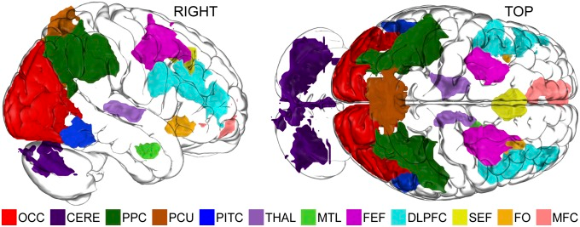 The initial set of ROIs included six masks from our previous work—five which were functionally defined in Montreal Neurological Institute space as well as one structurally-defined occipital (OCC) mask (Schlegel et. al, 2013). The locations of these six masks can be seen in Figure 4. The dorsolateral prefrontal cortex (DLPFC), frontal eye fields (FEF), occipital cortex(OCC), lateral occipital cortex (LOC—previously referred to as PITC), precuneus (PCU), and posterior parietal cortex (PPC) masks were transformed back into each subject’s native space.

To these six regions of interest that had previously been implicated as being part of a core network which facilitates the manipulation of mental imagery, we added four left hemisphere motor masks which were anatomically-defined in each subject’s native space using FreeSurfer’s cortical masks. The left primary motor cortex (mc) mask was defined as central sulcus, precentral gyrus, precentral sulcus--superior part and inferior part. The left premotor cortex (pm) mask was defined as the left half of superior frontal sulcus and middle frontal gyrus. The left supplementary motor area (sma) mask was defined as the posterior third of superior frontal gyrus and right half of superior frontal sulcus. The left pre-sma (psma) mask was defined as the middle third of superior frontal gyrus.

Fig. 4. The locations of the masks identified in our previous work can be seen here (Schlegel et. al, 2013).

After running analyses and finding significance in almost every region of interest, we decided to confirm our results by adding a more extensive set of controls. These additional masks consisted of all of the remaining masks shown above in Figure 4—cerebellum (CERE), thalamus (THAL), medial temporal lobe (MTL), supplementary eye fields (SEF), frontal operculum (FO), and medial frontal cortex (MFC)—as well as the right hemisphere analogues of the motor masks (with a _r appended to the mask name), bilateral somatosensory cortex (ss and ss_r) defined as postcentral gyrus, Brodmann area 9(ba9 and ba9_r) defined as the anterior third of the superior frontal gyrus bilaterally, and the bilateral frontal pole (fp) defined as the FreeSurfer mask G_and_S_transv_frontopol.

Multivariate Pattern Analysis: Classification

After principle components analysis (PCA) was used to denoise the data through dimension reduction, PyMVPA was used to carry out multivariate pattern analysis (MVPA; Hanke et. al, 2009). A four-way classification among L, R, F, and B rotations was carried out in each region of interest using spatiotemporal patterns for each correct-response trial, a linear Support Vector Machine (SVM) classifier, and leave-one-out cross-validation. One-tailed independent samples *t* tests were used to evaluate the significance of the classification accuracies compared with chance (25%). P values were false discovery rate (FDR) corrected. Another four-way classification was carried out to produce the confusion matrices shown later in Figure 7. These confusion matrices depict the breakdown of which types of rotations the classifier chose when presented with each of the four types of rotations in each ROI. Correlation analyses between the confusion model which represents the pattern of confusability built into the task, also shown later in Figure 6, and the confusion matrix of each ROI were carried out (FDR-corrected P ≤ 0.05). A paired sample t test was used to look at whether more information was present in motor areas for model group participants. Much of the analytic method was adapted from Schlegel et. al (2013).

RESULTS

While we look forward to analyzing the hand rotation data as well as continuing to analyze the mental rotation data, the two waves of analyses we have completed are presented here. As mentioned above, we first did the analysis with a core set of ROIs. We later repeated the analysis with a more extensive set of controls in order to make sure that our highly significant results were not a result of some analytic error.

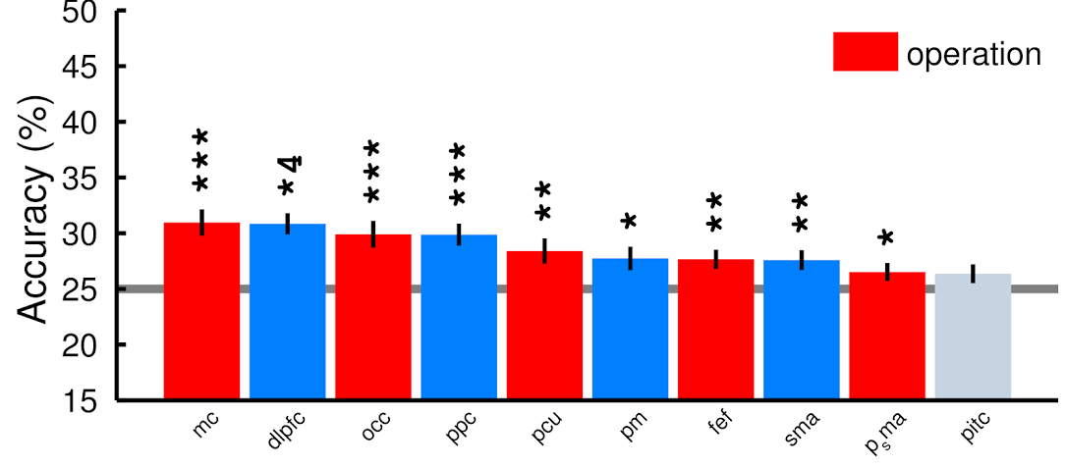Analyses Set 1—Core Set of ROIs

As can be seen in Figure 5 above, during the first iteration of our classification analyses, the ability of the classifier to classify which rotation out of four was the source of the data was significant in left primary motor cortex (pm), dorsolateral prefrontal cortex (dlpfc), occipital cortex (occ), posterior parietal cortex (ppc), precuneus (pcu), premotor cortex (pm), frontal eye fields (fef), supplementary motor area (sma), and pre-supplementary motor area (psma). Though it was close, we were not able to classify in lateral occipital cortex (pitc).

Fig. 5. The bar plot shows the classification accuracies with the highest accuracies at the left. The asterisks represent the different levels of significance achieved by the classification analysis in each ROI (*P ≥ 0.05; **P ≥ 0.01; ***P ≥ 0.001; *4, P ≥ 0.0001). Error bars show the standard error of the mean (SEM). Multiple asterisks indicate highly significant classification accuracies. All ROIs achieved significance except lateral occipital cortex (PITC).

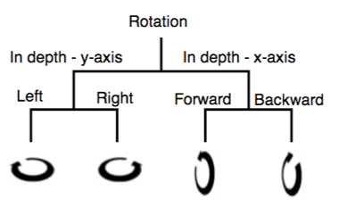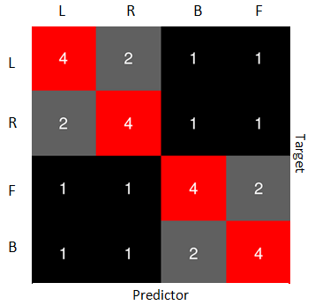Our next analysis involved comparing the confusion matrices generated for each ROI to the model of the confusion built into the task. The schematic shown on the left in Figure 6 represents the operation hierarchy we believe exists among the different types of mental rotations. According to this hierarchy, left and right in-depth rotations around the y-axis are more similar to each other than they are to either of the forward and backward in-depth rotations around the x-axis. Likewise, forward and backward rotations are more similar to each other than to left and right rotations. Given this model of similarity, we would expect the classifier to be more easily confused among more similar rotations. This hypothesis gave rise to the confusion model shown on the right in Figure 6. The labels on the left represent the mental rotation data the classifier is given, and the labels on the right represent the prediction in makes given that data. The numbers in the box represent the odds of the classifier choosing the label at the top given the data from the rotation represented by the label at the left. If the classifier had enough information to classify among the tasks, we would expect it to choose L most frequently when presented with data from a left rotation. Because of the similarity between left and right rotations, it may sometimes choose R, but we would expect this to be less common than choosing L. It should choose B and F less frequently than either L or R. We would not expect it to have a preference between B and F. These principles are all modeled in the confusion model. If the classifier has enough information to be able to pick up the pattern of confusability built into the task, we expect the confusion matrix generated by the four-way classification in that ROI to correlate strongly with the confusion model. The actual confusion matrices 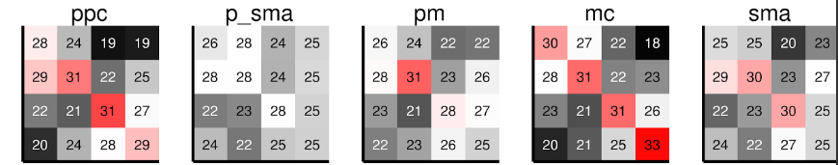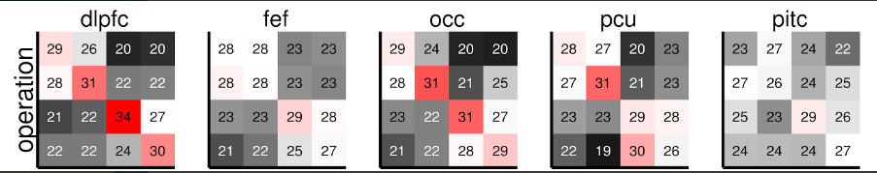generated in each ROI are shown in Figure 7.

Fig. 6. On left: The schematic represents the operation hierarchy we believe exists among the different types of mental rotations. According to this hierarchy, left and right in-depth rotations around the y-axis are more similar to each other and forward and backward in-depth rotations around the x-axis are more similar to each other. On right: We believe that this model of similarity would lead to the confusion model shown here. More similar operations would be more confusable to the classifier. The labels on the left represent the mental rotation data the classifier is given, and the labels on the right represent the prediction in makes given that data. The numbers in the box represent the odds of the classifier choosing the label at the top given the data from the rotation represented by the label at the left.

We believe that this correlation with the confusion model is an even better measure of whether or not a particular ROI has systematic information about the task than classification accuracy because our different types of rotations are confusable by design. The correlation of each of these confusion matrices with the confusion model is shown in Figure 8. A Fisher’s Z transform was applied 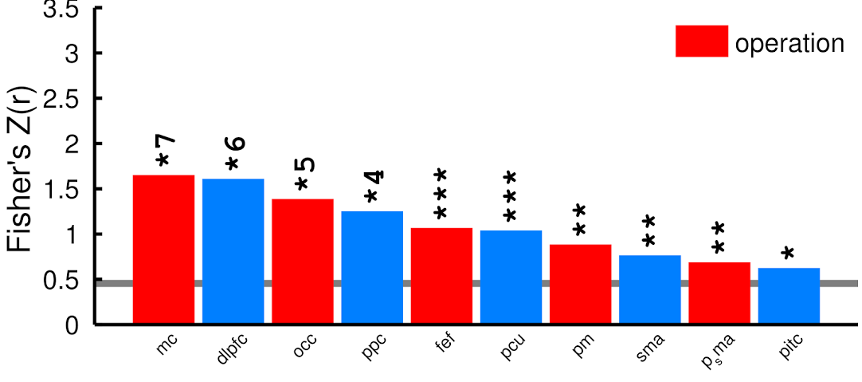to the correlations because the variance is normally not evenly distributed between 0 and 1. The correlation with the confusion model was significant—in some cases, very highly significant—in left primary motor cortex (pm), dorsolateral prefrontal cortex (dlpfc), occipital cortex (occ), posterior parietal cortex (ppc), precuneus (pcu), premotor cortex (pm), frontal eye fields (fef), supplementary motor area (sma), pre-supplementary motor area (psma), and lateral occipital cortex (pitc).

Fig. 7. These are the actual confusion matrices generated by a four-way classification in each ROI.

Fig. 8. The bar plot shows the confusion correlations with the highest correlations at the left. The asterisks represent the different levels of significance achieved by the classification analysis in each ROI (*P ≥ 0.05; **P ≥ 0.01; ***P ≥ 0.001; *4, P ≥ 0.0001). Multiple asterisks indicate highly significant classification accuracies. All ROIs achieved significance.

One final analysis was performed on this constrained ROI set to check if the classifier had been able to classify with a significantly greater amount of accuracy in motor areas for participants in the model training group compared to participants in the animation training group. A right-tailed independent samples t test was performed on the four left motor areas. There was a significant difference between the two training groups in 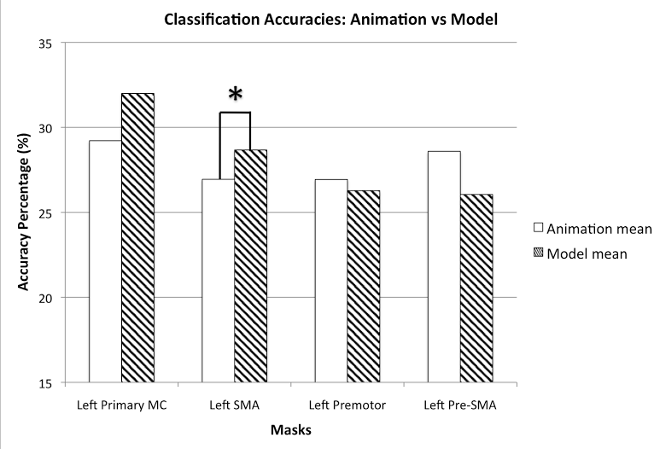the left supplementary motor area (sma) (t(20) = 2.05, p = 0.0269). See Figure 9 for results.

Fig. 9. The bar plot shows the differences in mean classification accuracy in left motor areas for participants in the model training group compared to participants in the animation training group. A right-tailed independent samples t test was performed on the four left motor areas. There was a significant difference (*P ≥ 0.05) between the two training groups in the left supplementary motor area (sma). (t(20) = 2.05, p = 0.0269).

Analyses Set 2—Core with Expanded Set of Control ROIs

Since the significance achieved in our initial set of ROIs was nearly universal, we decided to rerun the analyses with a highly expanded set of controls in order to make sure that our results were not false positives due to an error in the implementation of the analysis. The results of the four-way classifications to find classification accuracy and correlation with the confusion model can be seen below in Figure 10 and Figure 11, respectively.

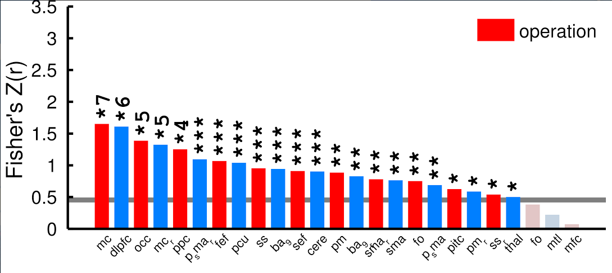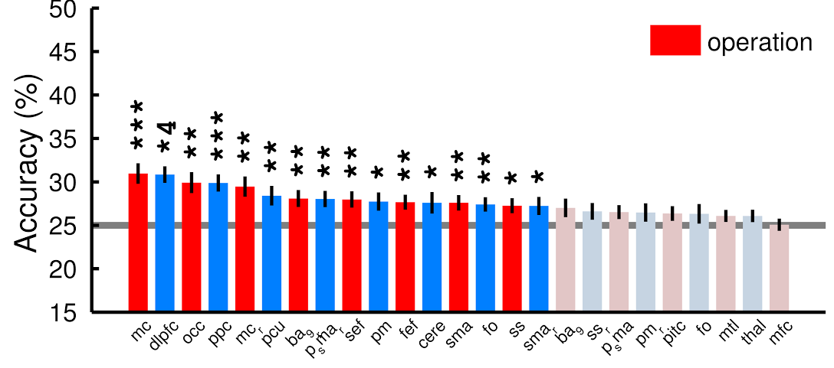

Fig. 11. The bar plot shows the correlation with the confusion model with the highest correlations at the left. The asterisks represent the different levels of significance achieved by the classification analysis in each ROI (*P ≥ 0.05; **P ≥ 0.01; ***P ≥ 0.001; *4, P ≥ 0.0001).Error bars show the standard error of the mean (SEM). Multiple asterisks indicate highly significant classification accuracies. A few ROIs did not achieve significance.

Fig. 10. The bar plot shows the classification accuracies with the highest accuracies at the left. The asterisks represent the different levels of significance achieved by the classification analysis in each ROI (*P ≥ 0.05; **P ≥ 0.01; ***P ≥ 0.001; *4, P ≥ 0.0001). Error bars show the standard error of the mean (SEM). Multiple asterisks indicate highly significant classification accuracies. Multiple ROIs did not achieve significance.

With the more extensive set of controls, classification accuracy did not reach significance in Brodmann area 9 (ba9), the right somatosensory cortex (ss_r), the right pre_sma (psma_r), the right premotor cortex (pm_r), the lateral occipital cortex (pitc), the frontal operculum (fo), the medial temporal lobe (mtl), the thalamus (thal), and the media frontal cortex (mfc). Correlation with the confusion model did not reach significance in the frontal operculum, the medial temporal love, and the medial frontal cortex.

DISCUSSION

One major outcome of this study is that our results were highly consistent with our past published work as well as with another study currently being written up for publication. The significant correlation of the confusion matrices of all of the initial set of ROIs with the confusion model supports the results of our previous work (Schlegel et. al, 2013). In our previous studies, multivariate pattern analysis (MVPA) was used to show that dorsolateral prefrontal cortex, occipital cortex, posterior parietal cortex, frontal eye fields, the precuneus, and the lateral occipital cortex all contained systematic information adequate to classify among different types of manipulations of mental imagery. In this study, the ability of the classifier to accurately classify among the four types of mental rotations and the correlation to the confusion model in each of these six areas was significant. This provides further evidence for the hypothesized existence of a widely distributed network which forms the core of the brain’s implementation of the mental workspace (Schlegel et. al, 2013). In addition, after adding the additional masks from our past work to our extended set of controls, we were not able to classify or correlate the confusion matrices in the same areas in which we had been unable to distinguish different types of manipulations of mental imagery. We therefore hypothesize that these ROIs—frontal operculum, medial temporal lobe, and medial frontal cortex in particular—may not be part of this highly distributed network.

While the masks we were unable to classify in seemed to be fairly logical, some of the masks we were able to classify in were surprising. We originally looked at left hemisphere motor masks because motor area control is contralateral. All of our participants were right-handed and entered input with their right hands. The participants in the model group rotated the models with their right hands. Previous studies have shown connections between mental and manual rotation (Wexler et. al, 1998). Therefore, we hypothesized that the left motor areas would be recruited by the core network. This seemed to be supported by our first set of analyses. However, when we added the right hemisphere analogues of these motor masks, we found we were also able to classify in many of the right motor masks—though to a lesser extent than in the left motor masks. Another puzzling discovery was that we were also able to classify in the left somatosensory cortex. Further review of the literature showed that both right motor areas and hand somatosensory cortex have been previously implicated in mental rotation (Cohen et. al, 1996).

The fact that we were able to classify better in the left supplementary motor area in participants who had undergone the model training than in those who had undergone the animation training demonstrated that training participants to approach the task a certain way may affect the extent to which various brain areas recruited to accomplish mental rotation. Going forward, we hope to analyze the differences between the two groups in more detail in order to gain a clearer understanding of our ability to execute mental rotations using different mechanisms. We also look forward to analyzing the hand rotation data and attempting to cross-classify with the mental rotation data. If we are successful in cross-classification—for example, training a classifier on mental rotation data and having it classify hand rotation data—that would be a strong test of the hypothesis that mental rotation and manual rotation have similar if not identical underlying neural bases.

In closing, it is important to keep in mind, that while we aimed to identify the details of the neural mechanisms underlying mental rotation, mental rotation was selected as a case study for the human ability to manipulate mental representations. Although distinguishing between similar types of mental rotations may be of more limited use, the need to form and manipulate mental representations is ubiquitous. A better understanding of our ability to manipulate mental representations would allow us to better understand our ability to intuit, visualize, and apply mathematical, scientific, and artistic principles—many of the abilities that distinguish us as humans.

REFERENCES

Cohen, M. S., Kosslyn, S. M., Breiter, H. C., DiGirolamo, G. J., Thompson, W. L., Anderson, A. K., Brookheimer, S. Y., Rosen, B. R., & Belliveau, J. W. (1996). Changes in cortical activity during mental rotation. A mapping study using functional MRI. Brain : a journal of neurology, , 89–8100.

Dale, A. M., Fischl, B., & Sereno, M. I. (1999). Cortical surface-based analysis. I. Segmentation and surface reconstruction. NeuroImage, 2, 179–194.

Desikan, R.S., Segonne, F., Fischl, B., Quinn, B.T., Dickerson, B.C., Blacker, D., Buckner, R.L., Dale, A.M., Maguire, R.P., Hyman, B.T., Albert, M.S., Killiany, R.J. (2006). An automated labeling system for subdividing the human cerebral cortex on MRI scans into gyral based regions of interest. *Neuroimage,* 31, 968-980.

Hanke, M., Halchenko, Y. O., Sederberg, P. B., Hanson, S. J., Haxby, J. V., & Pollmann, S. (2009). PyMVPA: A python toolbox for multivariate pattern analysis of fMRI data. Neuroinformatics, 1, 37–53.

Kosslyn, S. M., DiGirolamo, G. J., Thompson, W. L., & Alpert, N. M. (1998). Mental rotation of objects versus hands: neural mechanisms revealed by positron emission tomography. Psychophysiology, 2, 151–161.

Kosslyn, S. M., Thompson, W. L., Wraga, M., & Alpert, N. M. (2001). Imagining rotation by endogenous versus exogenous forces: distinct neural mechanisms. Neuroreport, 11, 2519–2525.

Michelon, P., Vettel, J. M., & Zacks, J. M. (2005). Lateral somatotopic organization during imagined and prepared movements. Journal of neurophysiology, 2, 811–822.

Peters, M. & Battista, C. (2008). Applications of mental rotation figures of the Shepard and Metzler type and description of a Mental Rotation Stimulus Library. Brain and Cognition, 66, 260-264.

Richter, W., Somorjai, R., Summers, R., Jarmasz, M., Menon, R. S., Gati, J. S., Georgopoulos, A. P., Tegeler, C., Ugurbil, K., & Kim, S. G. (2000). Motor area activity during mental rotation studied by time-resolved single-trial fMRI. Journal of cognitive neuroscience, 2, 310–320.

Schlegel, A., Kohler, P. J., Fogelson, S. V., Alexander, P., Konuthula, D., & Tse, P. U. (2013). Network structure and dynamics of the mental workspace. Proceedings of the National Academy of Sciences of the United States of America, 40,16277–16282.

Shepard, R.N. and Cooper, L. Mental images and their transformations. Cambridge, MA: MIT Press, 1982.

Shepard, R. N., & Metzler, J. (1971). Mental rotation of three-dimensional objects. Science (New York, N.Y.), 3972, 701–703.

Wexler, M., Kosslyn, S. M., & Berthoz, A. (1998). Motor processes in mental rotation. Cognition, 1, 77–94.